

Strategic Plan
2017 - 2023


Foreword by the Vice Chancellor
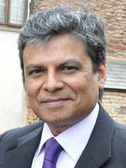
It is with great pleasure that I introduce the University of Liberal Arts Bangladesh’s Strategic Plan 2017-2023.
The Strategic Plan sets out the directions that we wish to take over the next decade in order to become the highest-ranked private university in Bangladesh. The Strategic Plan is the first step in achieving his ambition.
The Plan is the product of the hard work of many faculty and staff.
Together they have reviewed local and global directions, and trends in higher education and applied them to ULAB, developing comparative strategies that enable us to resource ULAB appropriately and provide our students with the very best in education in the Bangladesh context, developing a practical working road map for the future of ULAB.
It is now up to Faculty and Staff to ensure this occurs by translating our aims and objectives into achievable goals for all academic and administrative units of the University.

Professor Imran Rahman
Vice Chancellor (Acting)

Introduction: The Growing Vision

In 2004, the University of Liberal Arts (ULAB) was created on the model of the American liberal arts system, thereby setting itself apart from the majority of private and public universities in Bangladesh. These differences have been articulated in its vision and its mission statement, where it is stated unequivocally that ULAB will…
…instill in our students a high capacity for analytic thought, lucid expression and lifelong love of learning. Our graduates will be technologically sophisticated and globally aware people. They will be set free to explore, to create, to challenge. Imbued deeply with the principle of freedom, creativity and service, they will become leaders of society, capable of meeting all challenges of a new century.

ULAB has grown from around 400 students in 2004 to over 4000 in 2016, a clear indication of success in a highly competitive market. However, while growth is important to the university it is not the only criterion of success.
As a liberal arts university, ULAB strives to improve its profile in all areas: curriculum, administration, recruitment of well-qualified Faculty, and co-curricular activities.

Creating the Strategic Plan
As the university enters its second decade it is appropriate that its academic programs to be subjected to rigorous scrutiny in order to both evaluate its current performance and plan improvements for the future.
With this in mind, it was decided that a new strategic plan was required, covering the period 2016 to 2023. A representative committee of key stakeholders in ULAB's future was formed, comprising members of the faculty as well as administrative staff.
It was charged with devising a strategic plan for submission to the university’s Board of Trustees that would be the basis of development and growth over the next twelve years.
The committee met for two days in a retreat at the BRAC campus at Savar and considered the planning documentation provided by the Office of Academic Development. After extensive discussions, the committee agreed that the university should adopt a three-part strategy for development and growth. The three branches of the strategy are:
- Teaching and Learning,
- Research, and
- Engagement.
Under these branches a university-wide plan was devised, which will govern the future directions of ULAB, which in turn will be translated into Action Plans developed by the key units within the university – the academic departments, the research centers, and the core administrative units.
In adopting this trickle down model it is planned that the growth of ULAB will occur in a structured and logical manner.

Values
ULAB's core values are the standards that drive our culture, guide our conduct, and set the minimum expectations for everyone at ULAB. Our graduates aspire towards:
- Love of Lifelong Learning
- Practicing Integrity and Leadership
- Encouraging Innovation
- Promoting Tolerance
- The Pursuit of Excellence

Guiding Principles
- Liberal Arts: Providing a broad foundation across disciplines, in order to develop analytical abilities and flexibility of mind.
- Sustainable Development: Employing sustainable practices and respect for human rights, in order to become responsible leaders of the future.
- Progressive Education: Establishing values of tolerance, empathy and integrity, in order to become citizens of the world.
- Active Teaching and Learning: Striking a balance between theoretical and practical learning, in order to thrive in a fast-changing knowledge economy.
- Research: Supporting cross-disciplinary inquiry, in order to inform education and public policies.
- Engaged Citizenship: Building and serving civic communities, in order to create a free and equitable society.

PART I: THE THREE BRANCHES

1. Teaching and Learning

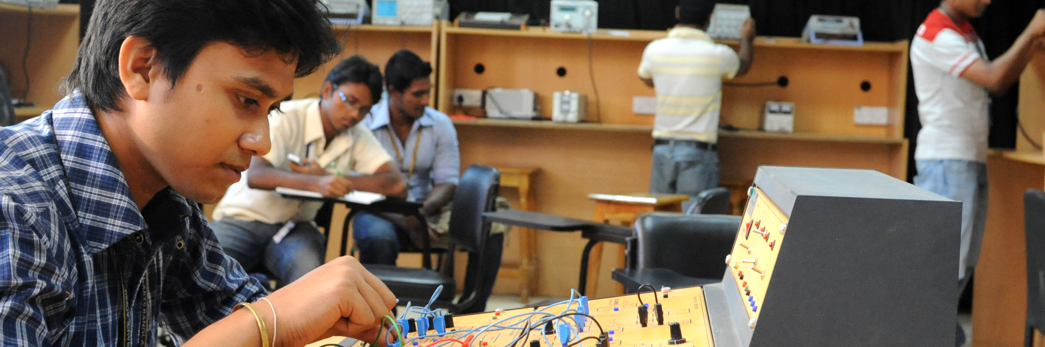

Strategies
By 2023 ULAB will be able to claim
- It is recognized as a regional center of excellence in teaching
- It attracts and supports excellent students from all backgrounds, but especially from English medium schools;
- It offers an attractive and distinctive curriculum;
- It delivers an outstanding students’ experience;
- It has developed an outstanding graduate education;
- It supports students in maximizing their leaning experience;
- It encourages and rewards excellence and creativity in teaching and learning
- It has produced technologically sophisticated graduates
- It offers all classes electronically via Moodle.

Targets
By 2023, ULAB can claim it: | Indicator
1.1 Attracts top students, based on A Level and HSC results, to its courses. | Commencement and completions of students reflect annual projected increases in suitable students
1.2 Achieves high level student satisfaction | Student satisfaction survey results
1.3 Achieves international recognition for the quality of its courses | Programs given full recognition for RPL foreign study by USA, UK, Canada and Australia
1.4 Increases student intake from leading English medium schools in Dhaka | Reflected in admissions data
1.5 Provide a sophisticated electronic learning environment for all students and faculty | Wide adoption of Moodle for class delivery and other social media.
1.6 Achieves enrolments of at least 30% per year in Graduate Certificate of Tertiary Teaching by Faculty | Design, offer and administer Graduate Certificate, recording enrolments
1.7 Introduces at least six new major courses between 2014 and 2020. | UGC and Board of Trustees approvals
1.8 Introduces at least six new postgraduate programs | UGC and Board of Trustees approvals
1.9 Ensures all faculty are trained in preparing courses for online learning via Moodle. | Handbook

2. Research



Strategies
By 2023 ULAB will be able to claim
- It has become a nationally recognized university for the excellence of its research in a variety of disciplines;
- It is recognized in the region as a center for excellence in research;
- It encourages, enables and supports research collaboration on a number of fronts;
- It has a university wide approach to creating, supporting and maintaining a research culture among its students and faculty;
- It is a university that recognizes and values excellence and diversity in all its forms thereby enhancing its research culture;
- It is a university recognized for addressing social, economic and intellectual challenges with a view to meeting societal demands thereby demonstrating the significance and impact of its research to the nation.
- Benchmark ULAB’s success against its major competitors.

Targets
By 2023 ULAB will | Enabler
2.1 Establish and maintain an internationally recognized research culture | The number of research grants obtained by faculty from both national and international grants bodies.
2.2 Create an internal research infrastructure | Appointment of Dean of Research and Research Office.
2.3 Attract students wishing to undertake higher degree studies by research | Enrollments
2.4 Improve research productivity | Increased number of research grants won by faculty; improved publication record and citation record

3. Engagement
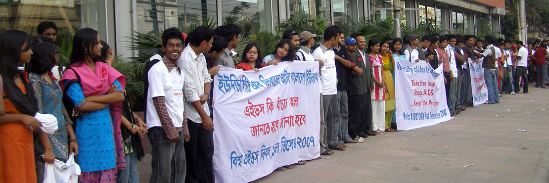

Strategies
By 2023 ULAB will be able to claim that it has
- Established strategic partnerships with key stakeholders in the community;
- Established public knowledge partnerships with public, private and non-government organizations;
- Developed public knowledge programs that contribute to debate on important issues;
- Increased the standing of the university within the community through alliances with high-ranking international universities and research institutions;
- Attract high caliber faculty from a range of countries;
- Created an active university alumni association;
- Created an internal network of engagement that works to the mutual benefit of the university community;
- Introduced a nationally recognized equity program;
- An active and well-organized co-curricular program;
- Created a center for knowledge dissemination through a well-organized program of public seminars, workshops, conferences and talks.

Targets
By 2023 ULAB will | Enabler
3.1 Establish and maintain a comprehensive program for faculty development | Regular workshops, retreats and seminars related to tertiary pedagogy
3.2 Contribute to public knowledge in Bangladesh in a structured way | Public lectures, seminars and workshops given by eminent faculty and visiting faculty
3.3 Increase the number of faculty with PhDs | Faculty lists
3.4 Create an active alumni association | Membership and activities
3.5 Create and maintain a mutually beneficial relation with the local community | Key stakeholder managed programs
3.6 Develop and maintain an active co-curricular program | Membership of clubs and programs of activities.
3.7 Improve the quality of cultural life at ULAB | Through exhibitions, concerts and seminars

PART II: THE ENABLERS

1. People

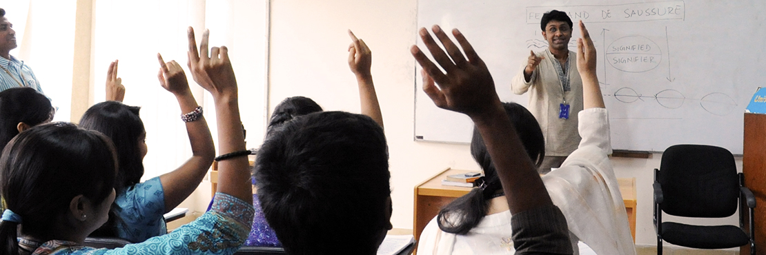
A university is only as good as its people!

Strategies
- Improve the university’s workforce flexibility by improving opportunities for faculty to meet their academic and human potential;
- Attract and retain the highest quality people to the university at all levels, from peon to professor by reviewing the university’s classifications structure and system of remuneration;
- Align performance of individuals with priorities of the university by developing diverse career paths for faculty;
- Invest in and attract high performing faculty and professional staff;
- Retain high performing faculty and staff with the introduction of incentive packages;
- Develop collaborative approach to teaching, learning and research among faculty;
- Improve the security of tenure of faculty and staff by linking rewards to performance.

Overall Target

Improve quality & performance of faculty to international levels by 2023.

Specific Target | Indicator
1.1 Create highest satisfaction rate among faculty of all Bangladeshi universities. | Recruitment and retention of high quality faculty.
1.2 Increase diversity of faculty. | Increased number of women in senior ranks of the university.
1.3 Increase the quality of the faculty. | Alignment of teaching and research with performance.
1.4 Increased professionalism of the faculty. | Increase in number of PhD holders at all levels.
1.5 Develop a system that rewards success. | Provide faculty with differing career paths, namely as Teachers, Teacher Scholars or Researchers.

2. Environmental Sustainability

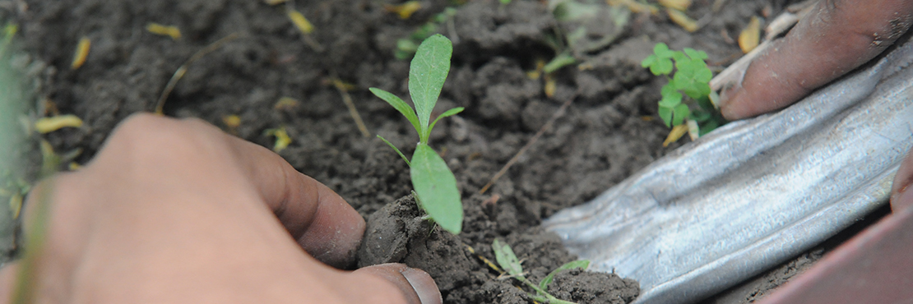
The inescapable challenges of the early Twentieth Century: sustainability and resilience, and the interconnected challenges of energy, water, food and climate.
Sir John Bridlington (UK Chief Scientific Adviser)

Strategies
ULAB will devise and implement a plan that sets targets to
- reduce energy consumption throughout the campus;
- reduce carbon emissions as a matter of urgency;
- reduce water consumption by harvesting rainwater;
- increase recycling through a university wide plan of waste management.

These will achieved with by implementing a comprehensive Green Plan that
- achieves international accreditation for ULAB’s sustainability programs that embed sustainable development in all teaching, learning, research and administrative practices.

Overall Target

By 2023 ULAB will lead Bangladesh in its reduction in energy consumption and waste management by meeting all set targets.

Specific Target | Indicator
2.1. Reduce energy consumption, water consumption and waste. | - 50% reduction on 2014 baseline energy consumption;  - 40% reduction on 2014 baseline carbon emissions;  - Annual reduction in water consumption by 50% by 2023.
2.2 Increased percentage of waste diverted to recycling | 80% of waste diverted to recycling.
2.3 Exceed best practices in construction of new buildings to maintain sustainability. | All new buildings to achieve a 5-star Green Star design rating.

3.Leadership and Management



Strategies
The success of the university in achieving its aims and objectives is dependent upon the quality of its leadership and management. Good leadership displays the qualities of planning, organizing, guiding and controlling all activities within the university.

Effective management fosters a university culture based on accountability, high performance, continuous improvement and innovation and rewards those who strive for excellence. Good management rewards those who successfully lead, manage and contribute to the university’s growth.

Effective management demonstrates a commitment to sustainability as a guiding principle of the university. Effective management harnesses the expertise of faculty and professional staff to achieve the goals of the university.

By 2023 ULAB will be able to claim that it has:
- Clearly defined responsibilities at all levels of management.
- Introduced new management divisions when and where necessary.
- Developed clear procedures for effective planning at all levels.
- Developed a culture of effective evidence based decision-making.
- Introduced an effective risk management program.
- Improved its performance based promotional protocols.

Overall Target
By 2023 ULAB will be able to claim that it has a quality leadership and management team that adheres to international best practices by:
- Maintaining transparent, efficient and effective management policies.
- Providing outstanding leadership in all professional areas.
- Creating a collaborative and coordinated approach to administration across divisional boundaries.
- Supporting rigorous planning and due diligence of all major initiatives.
- Developing effective communication strategies that allow informed decision-making across divisional boundaries.
- Introducing an effective risk management plan.
- Demonstrating a high degree of satisfaction among faculty and professional staff with the decision-making procedures.
- Demonstrating its accountability and transparency to its employees.

Specific Target | Indicator
3.1 Develop best practice in policy formation and decision- making. | High level of satisfaction demonstrated by Board of Trustees and Syndicate in the management plan adopted and performance of management team.
3.2 To provide outstanding leadership at all levels of the university’s operations. | Recruit suitable high quality personnel to fill senior positions.
3.3 Apply rigorous business financial planning criteria to all university activities. | Successful external auditing of ULAB procedures.
3.4 Improve levels of satisfaction of university management and leadership among all university faculty and staff | Improved performance indicators implemented.

4. Financial Sustainability

- ULAB will establish and maintain a robust financial position subject to rigorous scrutiny and audits.
- ULAB will maintain a fee structure commensurate with its status within the community and its long-term aims and objectives.
- ULAB will actively seek alternatives sources of funds, such as sponsorship and endowment, to augment its regular fee income.

Strategies
By 2023 ULAB will have developed strategies that cover the three principal financial domains:
- An effective Financial Management Plan that:
- Demonstrates prudent, responsible and financial management;
- Rigorous assessment of all requests and demands on its revenue before making decisions;
- Demonstrates budgetary transparency;
- Maintains commercial best practice in its financial decision-making;
- Ensure efficiency and effectiveness in financial operations.
- Revenue which:
- Optimizes revenues from existing sources;
- Develops new streams of revenue based on short courses, sponsorship and endowment;
- Encourages and rewards successful diversification in revenue raising;
- Maintain strategic, sustainable and diversified revenue growth.
- Expenditure that:
- Aligns expenditure with strategic goals;
- Minimizes expenditure growth;
- Develop strategic cost management programs;

Overall Targets
By 2023 ULAB will have achieved significant revenue growth that aligns expenditure with revenues that can be measured by:
- Attaining 100% revenue growth on 2014 figures;
- Increasing endowments to 20% of total revenue;
- The generation of increased surpluses through careful management of existing revenue sources and additional sources.

Specific Target | Indicator
4.1 Develop at least three new revenue streams. | Appointment of a Financial Planning Officer within the Finance Division.
4.2 Minimize expenditure by 5% per year relative to income. | Published budgets and introduction of an efficiency dividend
4.3 Generate increased cash flow through increased enrollments. | Improved Marketing program leading to increased enrollments
4.4 Nurture the Alumni Association as a source of future income with the setting of achievable targets. | Create an Alumni Office
4.5 Actively pursue endowments for the creation of endowed chairs etc. | Include in Financial Planner’s remit

5. Infrastructure

Future Plans
In this domain ULAB’s major strategy is to build a first-class quality green and sustainable campus that incorporates the latest in environmental, communication and educational technologies.
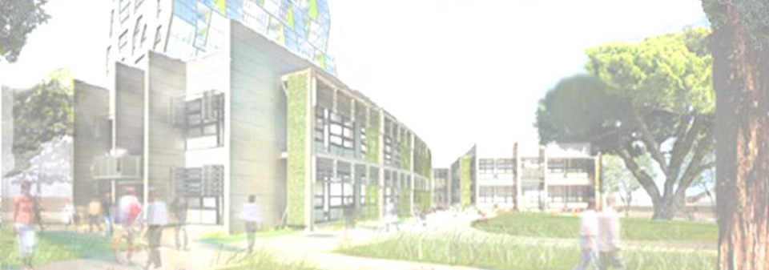

Building & maintaining a first-class green campus
The key enabler to the future directions of ULAB is its relocation to the purpose built Ramchandrapur Campus. The move from Dhanmondi has been mandated by the UGC and has to be carefully managed. The move raises a number of issues that have to be resolved:
  - Do we move the whole university and its programs on a date to be decided or will the move been phased in over time, program by program?
  - Who has ultimate responsibility for planning and implementing the move?
  - How do we promote the move in a positive light to our major stake holders?
  - When will a time line be created and who will manage it?
It is assumed that the design of the campus has begun and fully discussed with faculty. There is little point in expending so much time, money and effort on such a large and important project to find that critical facilities have been left out because the experts have not been consulted.
In addition it is critical that ULAB maintain a presence in Dhanmondi itself and thus Campus A should be retained, refurbished and become the major home for postgraduate programs as most postgraduate students work and Campus A remains a convenient place for them to study.

Current Strategies
- ULAB will continue to provide faculty, staff and students with a secure, well-managed and equipped environment in which to work and study.
- To continue to upgrade IT infrastructure to above average national standards, that supports teaching and research.
- ULAB aims to continue to provide students with a first class, secure and attractive educational environment.
- Create an environment that attracts high caliber faculty to the university ranks.
- Create an environment that generates student and faculty commitment the institution.

Overall Targets
By 2023 ULAB will improve its infrastructure and equipment by:
- Providing new, high quality, purpose built learning spaces on its new campus;
- Building the new campus on time and on budget;
- Developing a built environment governed by a fully developed sustainability plan;
- Regular upgrades of technology for the teaching programs and operational management.
Specific Target | Indicator
5.1 Build and maintain a new purpose built, state-of the-art green campus. | - a committee to oversee the transition from the current location to the Ramchandrapur campus;  - a project manager to organize and oversee the process of transition.
5.2 Complete all projects on time and on budget. | All financial milestones met.
5.3 Manage curriculum, environment and finances in a sustainable manner. | Successful implementation of effective reporting systems.

PART III: The Accountability Framework


To ensure that accountability is practiced at all university levels, it is essential that faculty and staff know their role in the system and behave accordingly.
- All reporting obligations are discharged through the Board of Trustees or their designated nominees, who are advised by the senior management of the university.
- Ultimate authority for operations resides in the Board of Trustees who delegates responsibilities to approved officers who assume responsibility for their portfolio.
- As far as practicable, responsibility is aligned with accountability and decision making devolved to the level best able to determine the means of implementation to achieve successful and efficient outcomes.
- All faculty and staff with management responsibilities work to clear operational goals, performance expectations and obligations.
- All recording responsibilities are coordinated through the office of the Vice Chancellor.
- Decisions are only taken on the basis of rigorous planning informed by detailed risk management assessment and expert review.
- All faculty and staff with responsibilities are expected to demonstrate a strong commitment to the ongoing improvement and management of the university.
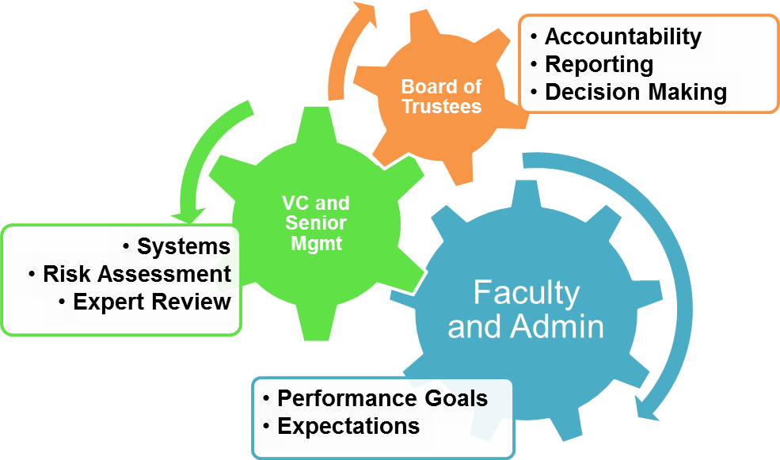

Key Elements in Achieving Goals
- A systematic approach to planning to achieve operational goals;
- The application of key performance indicators to achieve the alignment of responsibilities of senior management and published goals of the university;
- The introduction of a university Quality Assurance Framework;
- Careful formulation of the annual budget aligned with forward planning;
- All divisions within the university formulate a Strategic Performance Plan;
- Annual Strategic Performance Reviews of all divisions;
- A systematic approach to evaluation, reporting and quality assurance that promotes both effectiveness and efficiency and avoids unnecessary duplication;
- Clearly defined governance role for the Board of Trustees and its committees;
- A strong emphasis on risk management and assignment of accountability for risk management.
- Provide faculty, admin and students with a secure environment for work and study.

PART IV: Timeline
Stage | Responsibility | Activity | Date
1 | Senior Management | Review Draft Strategic Plan (SP) | Nov/Dec 2016
2 | Board of Trustees | Approve SP | Jan/Feb 2017
3 | HoDs/Div Heads | Discuss SP | March 2017
4 |  | Launch SP | May 2017
5 | Hods/Div Heads | Draft Annual Performance Plan (APP) | Ongoing
6 | Senior Management | Review APP | Ongoing
7 | HoDs/Div Heads | Revise APP | Annually
8 | HoDs/ Div Heads | Implement APP | On approval

This becomes the annual cycle of Performance and Risk Management with annual reviews of all departments and divisions occurring every April/May.

Appendix A

Annual Performance Plan (example)
No | Category | Activity | Budget | Risk Asses | Approved
1/14 | Curriculum | Introduce new MA | BDT | Yes; PVC | VC
2/14 | Faculty | Appoint 2 new Faculty | SL @ BDT  Ast Prof @ BDT | Yes; PVC | VC
3/14 | Investment | - Electronic equipment  - Books and journals  - Furniture * | BDT | Yes: PVC | VC
4/14 | Research | Itemize faculty research  projects ** | BDT | Yes/ DAD | VC
5/14 | Conferences | 4 Faculty to attend  national conference | BDT | Yes; VC | VC
 |  | 1 attend an international  conference | BDT | Yes/VC | VC
6/14 | Seminars | Organize 3 round tables, 2 workshops, 1 seminar *** | BDT | Yes/PVC | VC
7/14 | Publishing | Journal | BDT | Yes/VC | VC
 |  | 2 Book**** | BDT | Yes/VC | PVC

* See Attachment 1
** Debited to University Research Budgets for Departments; actual costs for Research Centers
*** Details Attachment 2
**** Details Attachment 3

